Tic Tac Toe Game with AI

**OBJECTIVES**

* Develop Artificial intelligence-based tic-tac-toe game for human Vs AI by implementing minimax algorithm with adversarial search concept
* It mainly consists of developing and implementing a computer program that plays Tic Tac Toe against another player.
* We can learn the process of project development.

**INTRODUCTION**

* Your task in this project is to implement the game tic-tac-toe, including a simple computer player.
* The game is played on a 3 × 3 board; the human player goes first and places an “X” on the board, then the computer places an “O”, and so on, until either one player gets three in a row (a winning position) or there are no more moves.

**FLOWCHART**

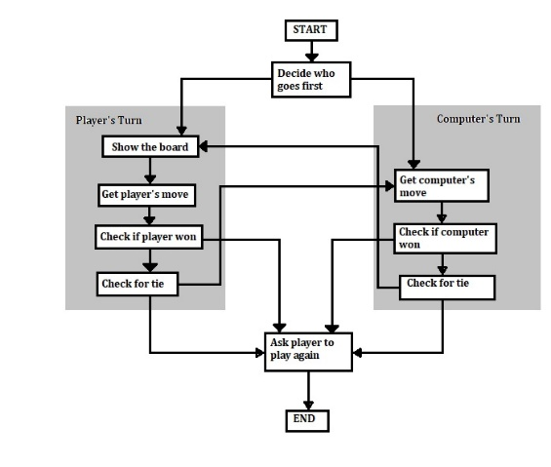

**CONCLUSION**

The player who succeeded in placing three respective marks in a horizontal, vertical, or diagonal row wins the game. The Tic Tac Toe is a great way to pass your free time whether you're standing in a line or spending time with your kids

**OUTPUT**

. 